Nama : Frederico Steven Kwok
NPM : 242310037
Kelas : TI-24-PA1
Mata Kuliah : Lab. Pemrograman Web
Tugas : Pertemuan 7 – Tugas dan Latihan 6
Github : https://github.com/RicoSteven120206/PW-MERN-STACK-242310037.git
Dokumentasi Lengkap Source Code Berada di Repository Github
- Buatlah halaman form.jsx yang berfungsi sebagai form input data buku pada modul CMS. Form tersebut harus memiliki beberapa field seperti Book Title, Author Name, Type Book, Sinopsis, Story, serta fitur Upload Image. Dalam proses pembuatannya, gunakan kembali komponen UI Forms global yang telah dibuat sebelumnya agar tampilan form tetap konsisten dan kode lebih modular.
- Berikan Source Code Form dan Index CMS Books
Source Code components/cms/_books/components/form.jsx
"use client";
import React, { useEffect, useState } from 'react';
import { TextAreaInput, TextInput, InputImage, InputCheckbox } from '@/components/ui/forms';
import { Button } from "@/components/ui/buttons";
import { openModal, ModalResponse } from '@/components/ui/modals';
import { Alert } from '@/components/ui/alerts';
import ListBooks from '../../../../const/bookList';

const GET_BOOK_BY_ID = async (id) => {
return new Promise((resolve) => {
setTimeout(() => {
const book = ListBooks.find((b) => b.id === Number(id));
if (book) {
resolve({ success: true, data: book, message: "" });
} else {
resolve({ success: false, data: null, message: "No record found" });
}
}, 300);
});
};

const CREATE_BOOK = async (formDataToSend) => {
return new Promise((resolve) => {
setTimeout(() => {
const newBook = {
id: Date.now(),
title: formDataToSend.get('title'),
author: formDataToSend.get('author'),
sinopsis: formDataToSend.get('sinopsis'),
story: formDataToSend.get('story'),
is_free: formDataToSend.get('is_free') === 'true',
img: "default_cover.png",
rating: 5.0,
views: 0
};
ListBooks.unshift(newBook);
resolve({ success: true, message: "Book created successfully" });
}, 500);
});
};

const UPDATE_BOOK = async (id, formDataToSend) => {
return new Promise((resolve) => {
setTimeout(() => {
const index = ListBooks.findIndex((b) => b.id === Number(id));
if (index !== -1) {
ListBooks[index] = {
...ListBooks[index],
title: formDataToSend.get('title'),
author: formDataToSend.get('author'),
sinopsis: formDataToSend.get('sinopsis'),
story: formDataToSend.get('story'),
is_free: formDataToSend.get('is_free') === 'true',
};
resolve({ success: true, message: "Book updated successfully" });
} else {
resolve({ success: false, message: "Book not found" });
}
}, 500);
});
};

export default function Form({ book_id, ReloadBook }) {
const obj_book = {
title: '',
author: '',
sinopsis: '',
story: '',
is_free: false,
image: null
};

const [formData, setFormData] = useState(obj_book);
const [imagePreview, setImagePreview] = useState(null);
const [error, setError] = useState("");

const ReloadBookByID = async () => {
const result = await GET_BOOK_BY_ID(book_id);
if (result.data && Object.values(result.data).length > 0) {
setFormData(result.data);
if (result.data.img || result.data.image) {
const imageUrl = result.data.img || result.data.image;
setImagePreview(imageUrl);
}
} else {
openModal({ message: <ModalResponse message={result.message} title={"No record found"} /> });
setFormData(obj_book);
}
};

useEffect(() => {
if (book_id) {
ReloadBookByID();
}
}, [book_id]);

const handleInputChange = (e) => {
const { name, value, type, checked } = e.target;
setFormData(prev => ({
...prev,
[name]: type === 'checkbox' ? checked : value
}));
};

const handleImageChange = (e) => {
const file = e.target.files[0];
if (file) {
const validTypes = ['image/jpeg', 'image/jpg', 'image/png'];
if (!validTypes.includes(file.type)) {
setError('Please select a valid image file (JPEG, or PNG)');
return;
}

if (file.size > 5 * 1024 * 1024) {
setError('Image size must be less than 5MB');
return;
}

setFormData(prev => ({ ...prev, image: file }));
setError(null);

const reader = new FileReader();
reader.onloadend = () => {
setImagePreview(reader.result);
};
reader.readAsDataURL(file);
}
};

const handleSubmit = async (e) => {
e.preventDefault();
try {
const formDataToSend = new FormData();
formDataToSend.append('title', formData.title);
formDataToSend.append('author', formData.author);
formDataToSend.append('sinopsis', formData.sinopsis);
formDataToSend.append('story', formData.story || '');
formDataToSend.append('is_free', formData.is_free);

if (formData.image instanceof File) {
formDataToSend.append('coverImage', formData.image);
}

if (book_id) {
formDataToSend.append('id', book_id);
const result = await UPDATE_BOOK(book_id, formDataToSend);

if (result.success) {
openModal({
message: <ModalResponse
message="Book has been successfully updated!"
title="Success"
/>
});
ReloadBook();
setFormData(obj_book);
setImagePreview(null);
} else {
setError(result.message || 'Failed to update book');
}
} else {
const result = await CREATE_BOOK(formDataToSend);
if (result.success) {
openModal({
message: <ModalResponse
message="Book has been successfully created!"
title="Success"
/>
});
ReloadBook();
setFormData(obj_book);
setImagePreview(null);
} else {
setError(result.message || 'Failed to create book');
}
}
} catch (err) {
setError(err.message);
}
};

return (
<form onSubmit={handleSubmit}>
<h3 className='d-flex align-items-start flex-column'>
<span className="">{book_id ? "Edit Book" : "Add New Book"}</span>
<span className="text-secondary fs-6">
{book_id ? "Update the details for this book." : "Fill in the details for the new book."}
</span>
</h3>

<div className="row">
<div className="col-lg-6">
<TextInput
title="Book Title"
name="title"
value={formData.title}
onChange={handleInputChange}
required
/>
<TextAreaInput
title="Sinopsis"
name="sinopsis"
value={formData.sinopsis}
onChange={handleInputChange}
rows={2}
required
/>
<TextAreaInput
title="Story"
name="story"
value={formData.story || ''}
onChange={handleInputChange}
rows={3}
/>
</div>

<div className="col-lg-6">
<div className="row">
<div className="col-8">
<TextInput
title="Author Name"
name="author"
value={formData.author}
onChange={handleInputChange}
required
/>
</div>
<div className="col-4">
<InputCheckbox
title="Type Book"
value="Is Free"
name="is_free"
is_switch={true}
checked={formData.is_free}
onChange={handleInputChange}
/>
</div>
</div>

<InputImage
title="Cover Image"
onChange={handleImageChange}
required={!book_id}
imagePreview={imagePreview}
/>
</div>
</div>

{error && (
<div className="mt-4">
<Alert message={error} variant='danger' />
</div>
)}

<div className="mt-4 text-center">
<Button
type="button"
variant="light"
className="me-2 btn-lg"
onClick={() => openModal({ open: false })}
>
Cancel
</Button>
<Button type="submit" variant="primary" className="btn-lg">
{book_id ? "Update Book" : "Submit Book"}
</Button>
</div>
</form>
);
}
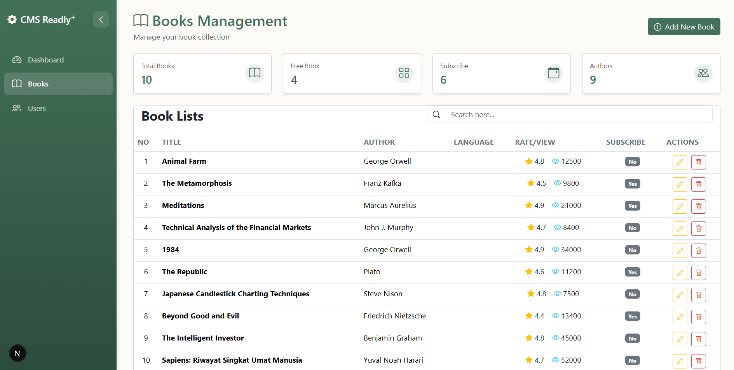
- Implementasikan sebuah tombol Add New Book pada halaman manajemen buku. Ketika tombol tersebut diklik, jalankan properti fungsi handleAdd untuk memanggil sebuah popup modal yang menampilkan komponen Form. Modal tersebut akan digunakan sebagai antarmuka untuk melakukan proses penambahan data buku baru (Add New Book) berdasarkan field yang telah dibuat pada komponen form.jsx.
- Source Code /components/cms/_books/index.jsx
"use client";

import React, { useEffect, useState } from "react";
import { openModal } from "@/components/ui/modals";
import { Alert } from "@/components/ui/alerts";
import { Skeleton } from "@/components/ui/loading";
import { CardCalculates } from "../components/card_calculates";
import { Header } from "./components/header";
import Form from "./components/form";
import Tabledata from "./components/tabledata";
import ListBooks from '../../../const/bookList';

const GET_ALL_BOOK = async () => {
return new Promise((resolve) => {
setTimeout(() => {
resolve({
loading: false,
data: ListBooks,
message: "",
});
}, 500);
});
};

export function MBooks() {
const [books, setBooks] = useState({ loading: true, data: [], message: "" });

const ReloadBook = async () => {
setBooks({ loading: true, data: [], message: "" });
const results = await GET_ALL_BOOK();
setBooks(results);
};

useEffect(() => {
ReloadBook();
}, []);

const totalAuthors = new Set(books?.data?.map((b) => b.author).filter(Boolean)).size;

return (
<div className="container-fluid">
<Header
handleAdd={() => openModal({ message: <Form ReloadBook={ReloadBook} />, size: "xl" })}
/>

<div className="row">
<div className="col-md-3">
<CardCalculates
title={`Total Books`}
value={books?.data?.length || 0}
icon={`book`}
/>
</div>
<div className="col-md-3">
<CardCalculates
title={`Free Book`}
value={books?.data?.filter((b) => b.is_free).length || 0}
icon={`grid`}
/>
</div>
<div className="col-md-3">
<CardCalculates
title={`Subscribe`}
value={books?.data?.filter((b) => !b.is_free).length || 0}
icon={`calendar-event`}
/>
</div>
<div className="col-md-3">
<CardCalculates
title={`Authors`}
value={totalAuthors}
icon={`people`}
/>
</div>
</div>

{books.loading ? (
<Skeleton />
) : books.message ? (
<Alert message={books.message} variant="danger" />
) : books.data && books.data.length > 0 ? (
<Tabledata data={books.data} ReloadData={ReloadBook} />
) : (
""
)}
</div>
);
}

export default MBooks;
Output Dari Source Code Menambahkan/ Add Book
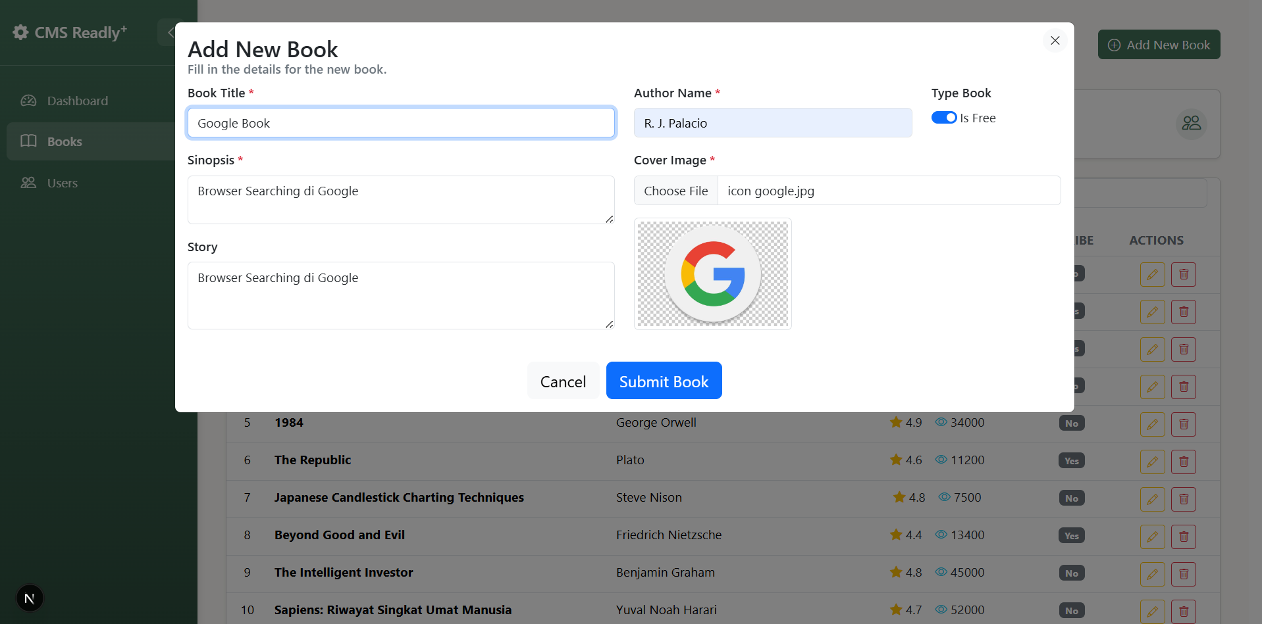
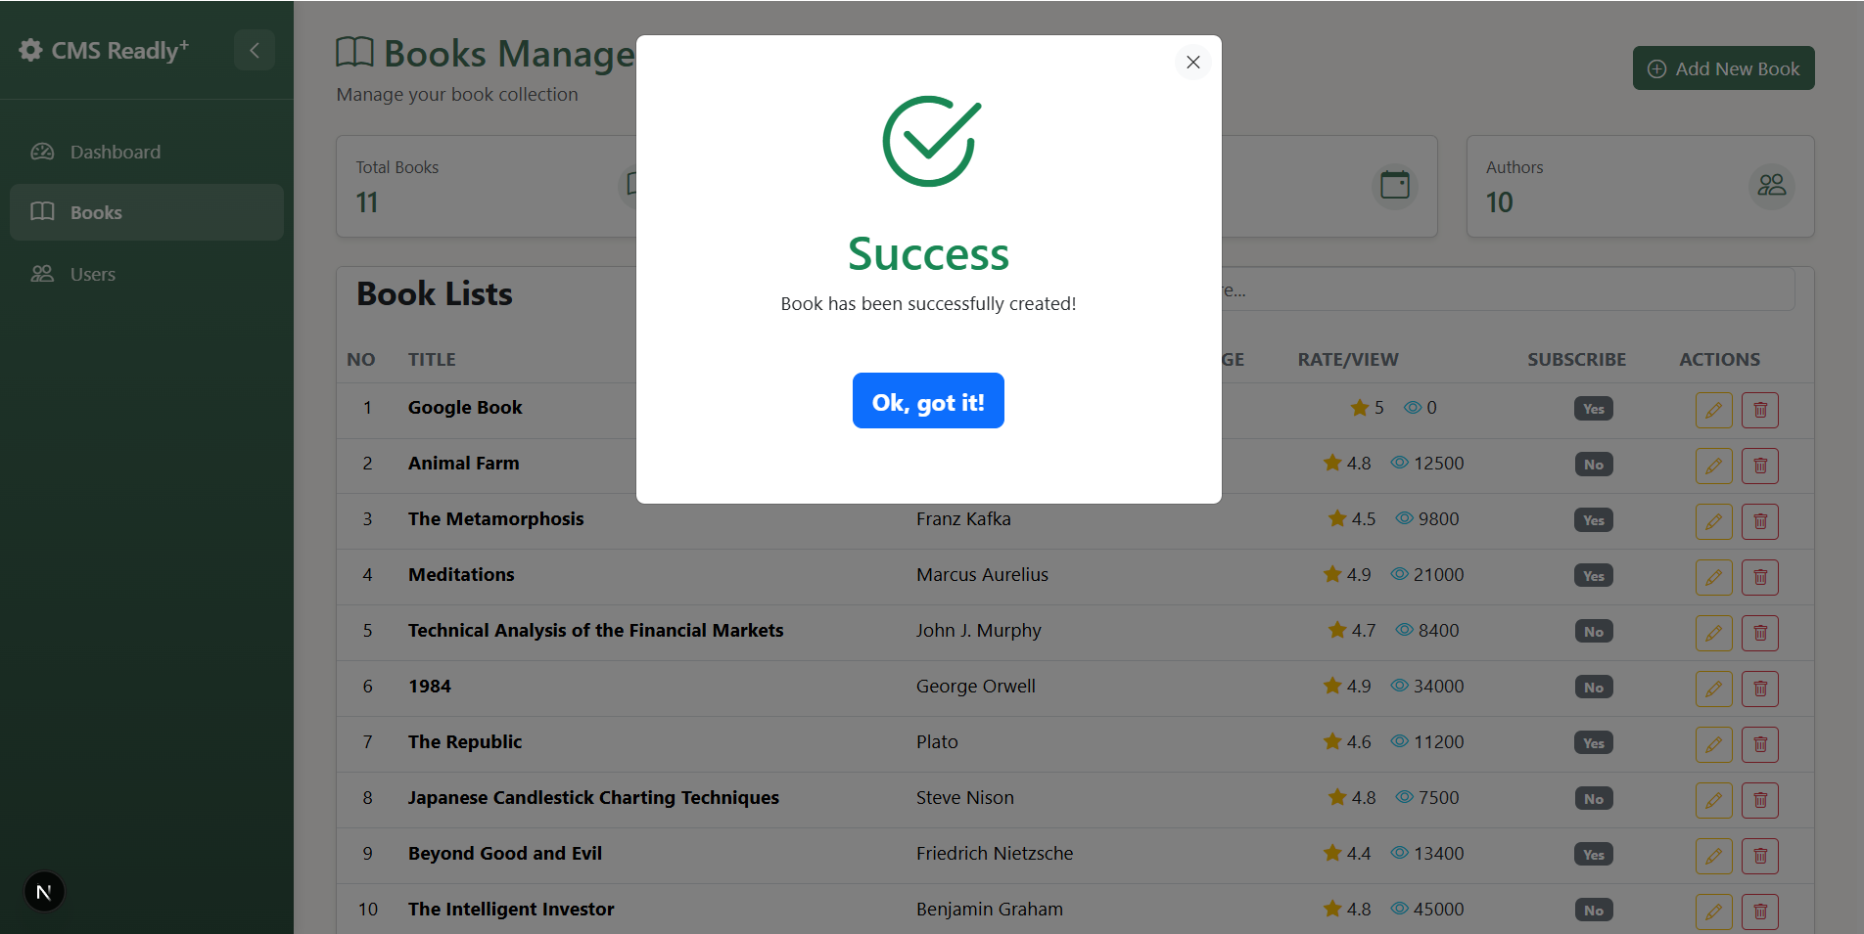
- Buatlah dokumentasi dalam mengerjakan soal Latihan Pembelajaran, dengan memberikan Screenshot baik dari sisi aplikasi ataupun code yang sudah dimodifikasi dengan penjelasandan alur yang baik dan benar. Dokumentasi disimpan dalam bentuk PDF dan ditaruh dalam project web yang telah anda kerjakan.
- Done. Pengerjaan Dokumentasi Selesai.
- Upload project tersebut pada GITHUB dengan menggunakan repository bernama "PW-MERN-STACK-NPM" dengan nama commit “Praktikum 5”.
Link GITHUB PW-MERN-STACK-242310037
https://github.com/RicoSteven120206/PW-MERN-STACK-242310037.git

